**Aim:- Practical Implementation of Decision Tree using R Tool.**

1. **install.packages("party").**
2. **Input Data:**

# Load the party package. It will automatically load other

# dependent packages.

library(party)

# Print some records from data set readingSkills.

print(head(readingSkills))

1. **When we execute the above code, it produces the following result and chart –**

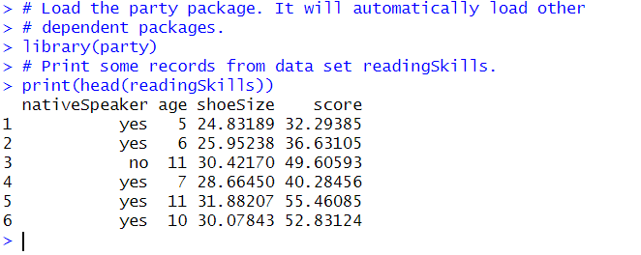

1. **We will use the ctree() function to create the decision tree and see its graph.**

**Practical Code:**

# Load the party package. It will automatically load other

# dependent packages.

library(party)

# Create the input data frame.

input.dat <- readingSkills[c(1:105),]

# Give the chart file a name.

png(file = "decision_tree.png")

# Create the tree.

output.tree <- ctree(

nativeSpeaker ~ age + shoeSize + score,

data = input.dat)

# Plot the tree.

plot(output.tree)

# Save the file.

dev.off()

**Output:**

